## WET 4.0.3

Like last year, the client is using WET 4.0.3.

Here is a page including working examples of WET code:

<http://wet-boew.github.io/wet-boew/demos/index-en.html>

I provide this in case you want to include WET code to provide a certain feature.

## Dreamweaver Access

For this project, I will need you to work on the server. This way, we can ensure the WET features are working correctly.

URL/FTP: wet4.marketaccess.ca

Password: tZ3w.YsHYndpyN35

This is the same server and directory you worked on last year. I left the old WET files there in case you need to reference them. If this is confusing, let me know and I’ll remove them.

The client would like 8 documents converted initially. More documents are coming. I’m expecting another 10 to 12 documents quickly, so please get started on this right away. I’ve placed the source documents (both PDF and HTML) in:

wet4.marketaccess.ca/2015-sourcedocs

The directory also includes this write up, it’s called approach-for-mina.docx

## Initial Sample

Similar to last year, initially the client would like a sample to demonstrate and verify our approach. Please create the HTML for English Parts Person:

* wet4.marketaccess.ca/2015-sourcedocs/partsperson_noa2015eng.pdf
* Word document is also in the directory

I present the approach on the pages to follow.

## Approach

* The documents are to be converted to HTML 5 with encapsulated text for characters with accents, for example É will be coded as &Eacute;
* As mentioned, the English and French source documents (Word and PDF) are contained in:   
  wet4.marketaccess.ca/2015-sourcedocs
* The documents are to follow the example shown at:   
  <http://www.red-seal.ca/trades/auto_paint/2014noa_overview@-eng.jsp>   
    
  I asked the client to send the HTML for this document and it’s in   
    
  <http://wet4.marketaccess.ca/2015-example/raw-html/>   
    
  We took one of the raw HTML files and placed it into the pre-existing pages you used last year:

<http://wet4.marketaccess.ca/2015-example/2A51-WEB-2014autopaint_overview_eng--WEB-20150316-v01-JC.html>   
  
Notice, the template is applied correctly and the code works. As you scroll down, you will see the ToC for the section shows up on the bottom. If you click the ToC link, the ToC for the section appears in the right. The ToC for the document appears in the left column.   
  
Please use this page as a template for the English documents you create. You can use any of the HTML files from the raw-html folder, but I want the template header and footer added so I can verify the table of contents and other elements are working correctly.   
  
For French pages, create a French template from the files on the server.

* The code cannot have two spaces in the text (such as between sentences) otherwise there CMS system will add the character ‘Â’ to the first space, or few spaces.
* Quotation marks (“ ”) need to be coded &rdquo; &ldquo;
* Apostrophe needs to be coded &rsquo; (otherwise this will show up ‘â€™’)  
  The documents will be converted into separate HTML documents by section.
* Notice the source document has ToC and headings in ALL CAPS, but it is to be input as Title Case in English. In the case of French, only the initial letter is capitalized.
* For the ToC, use an approach similar to the approach used in the sample document:   
    
  <http://www.red-seal.ca/trades/auto_paint/2014noa_overview@-eng.jsp>   
  + ToC for the document sections is in the left column
  + ToC for the section is contained in the right side
  + Notice as you scroll down, the Page Content Menu shows.
  + All of the above are controlled automatically if correct code is applied
  + Ensure you use the code provided in the English sample
  + For French documents, use correct approach shown in French documents contained in:   
      
    <http://wet4.marketaccess.ca/2015-example/raw-html/>
* English and French files are to be saved in the same directory.
* Create unique directory for each document. Use 2015-nameoftrade
  + First sample directory will be http://wet4.marketaccess.ca/2015-partsperson/
* HTML file naming convention:   
  2A51-WEB-2014welder_appendix a_eng--WEB-20150302-v02-MAC  
  + These remain the same for all pages
  + Name of the trade
  + Name of the page (block a, overview..)
  + Language (fra or eng)
  + Date (YYYY MM DD)
  + Version
  + Create files as .html. Link in ToC and within documents as .html. The .jsp link will be added when client inputs into their CMS.

## Conversion Notes

When creating the initial and subsequent documents, please use the example provided as a reference:   
  
<http://www.red-seal.ca/trades/auto_paint/2014noa_overview@-eng.jsp>

And follow the instructions provided in this document.

You can view the raw html on our server as mentioned.

**You will not be required to convert the entire document. This is true for all documents.** The first 14 pages (with the exception of the Acknowledgements section) are not converted completely. You start the main conversion from the **Scope** section which starts directly under the heading **Analysis**

Below I’m going I detail the steps to convert the document. Ensure the pages are placed within the template so the completed document can be viewed on the server:

**Overview Page**

* 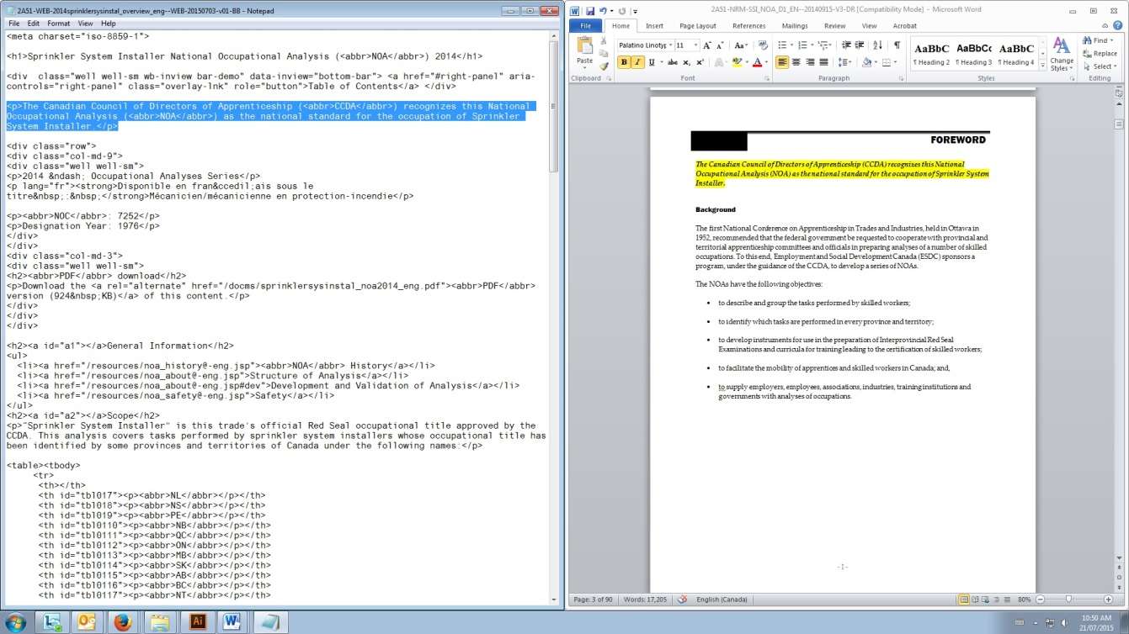Using the template, include the initial paragraph from the Foreword in the source document
* Now add title in opposite language and NOC into HTML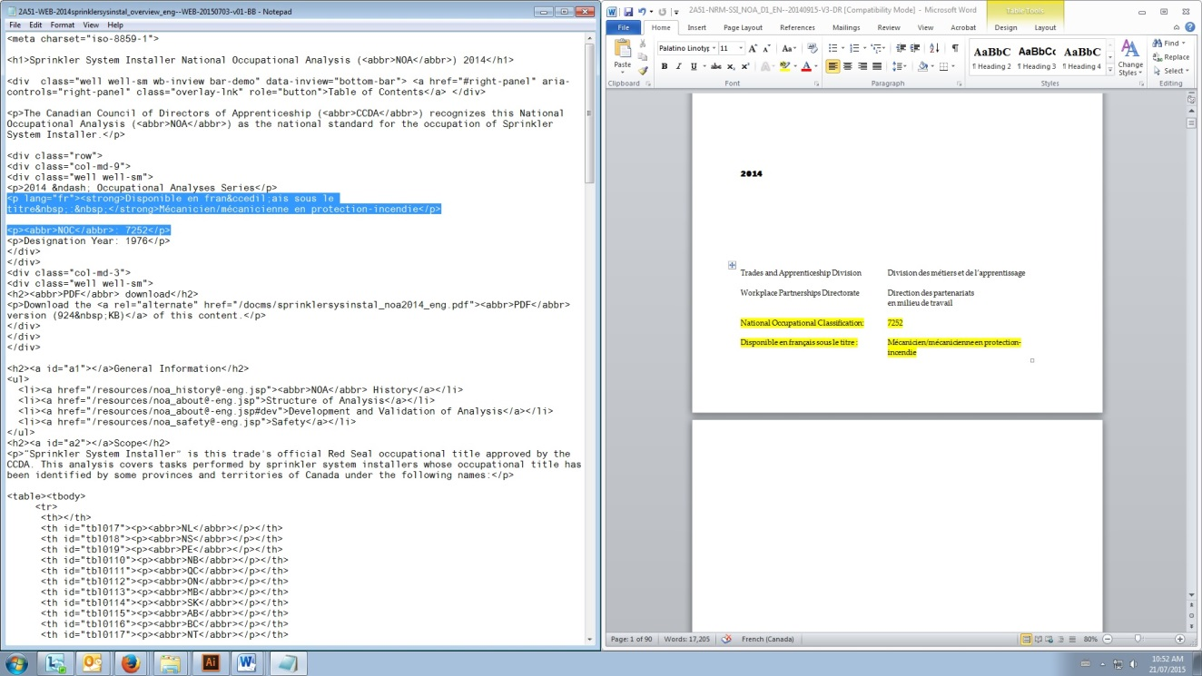
* Next, add designation year from the table below:

|  |  |  |  |
| --- | --- | --- | --- |
| **Trade** |  | **Designation Year** | **NOC** |
| Tool and Die Maker |  | 1992 | 7232 |
| Truck and Transport Mechanic NOA |  | 1984 | 7321 |
| Partsperson |  | 1991 | 1522 |
| Sheet Metal Worker |  | 1958 | 7233 |

* Now include the **General Information** section (just copy and paste, it’s the same for any trade)  
    
  <h2><a id="a1"></a>General Information</h2>  
  <ul>  
   <li><a href="/resources/noa_history@-eng.jsp"><abbr>NOA</abbr> History</a></li>  
   <li><a href="/resources/noa_about@-eng.jsp">Structure of Analysis</a></li>  
   <li><a href="/resources/noa_about@-eng.jsp#dev">Development and Validation of Analysis</a></li>  
   <li><a href="/resources/noa_safety@-eng.jsp">Safety</a></li>  
  </ul>
* Add SCOPE from source document
* Add OCCUPATIONAL OBSERVATIONS section source document
* Add ESSENTIAL SKILLS SUMMARY section   
    
  * not all trades have this, but there is an example here - <http://www.red-seal.ca/trades/weld/2014noa_01_overview@-eng.jsp>  
    
  The summaries for the essential skills should use expand and collapse coding. This is supplied in the sample (raw) html.
* Add ACKNOWLEDGEMENTS / contact info section
* Add Navigation Bar for right side and ToC to left

**Additional pages**

* Ensure ToC code is present for entire document on the left
* Ensure ToC for section is present on the right side
* Each remaining section of the document is to be coded as individual HTML document. See sample document:   
    
  <http://www.red-seal.ca/trades/auto_paint/2014noa_overview@-eng.jsp>   
    
  and reference raw HTML provided on the server for appropriate approach and code.
* Note each section uses tables sparingly. Although the source document has column type layout. The approach is revised in the HTML. This is important.
* Looking at the document you are to convert, looking at page 20, Bloke A:
  + Heading tags are to be used for
    - Context
    - Trends
    - Related Components
    - Tools and Equipment
  + For the items under **Task 1 Performs safety-related functions**
    - Use bullets for each item (K 1, K 2, etc.) and remove extra spaces between item and description.
  + Tables are only used for Sub-Task items.
* Repeat for other blocks